KINDER TEACHERS:  Ms. Barcenas- (Classroom #28)  Ms. Cortes -(Classroom #13)  Ms. Johnson- (Classroom #31) | NEWSLETTER # 1  September 2023  ¡Welcome to Kinder!  2023-2024  
September 4, 2023- Labor Day Holiday! (No school!)
September 25, 2023-Fall Holiday! (No school!)
. Objectives:  - Reading Integrated with Social Studies: Nursery Rhymes and Fables, Culture  - Language Arts : environmental noises, words within sentences, sounds within a words  - Writing: Practice writing strokes  - Math: Numbers to 10  - Science: Weather  ** HFW: you, my, and, we, all, be, me, little, in, if  Please help your child to read, spell, write and use the high frequency words in a complete sentence. ** | Classroom Rules  1-Work silently.  2-Respect your peers.  3-Follow directions.  4-Raise your hand to speak or stand from seat.  *** Parents please review our classroom rules with your child. Thank you. *****  Uniforms  Parents this year students need to wear red or white polo shirt or the Golfcrest t-shirt. Pants can be blue or khaki pants. On Fridays, they may wear jeans along with the red Golfcrest spirit shirt or a college shirt. Jeans with holes are not allowed. Boys are not allowed to wear earrings.  School Hours:  Breakfast is served at 7:30 a.m. Please send your child to school on time.  School hours: 7:30-3:00 p.m.  This school year our principal will be tracking tardies. Please send your child to school on time every day.  Dismissal is from 2:50-3:00p.m. . Please arrive on time due to heavy traffic around the school.  If you wish to change your child’s method of dismissal, you will need to make the change in the school office.

Notes to remember:  - Please check your child’s backpack daily for flyers and homework.  Homework is turned in every Friday.  - If you wish please send a snack and a bottle of water for your child to have in the afternoon after lunch between the hours of 1:00-2:00.  - *If you have any questions or concerns please send me a note in your child’s homework folder. This is a valuable tool to communicate! You can also send a message through Class Dojo.  - *Please send an extra pair of clothing in a bag labeled with your child’s name. This is in case your child needs a pair of extra clothing in case of an accident or spilled milk etc, . . .  *Some school areas are very cold. Please send your child with a light jacket or sweater daily.* | Communication Method 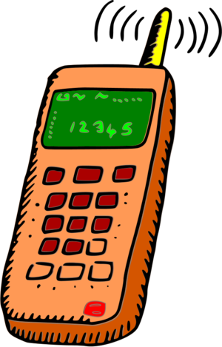  Home Resources  School Telephone Number: (713)845-7425  Email:  mbarcena@houstonisd.org (Ms. Barcenas)  P00173318@houstonisd.org (Ms. Cortes)  Eboni.johnson@houstonisd.org (Ms. Johnson  Class Dojo    Lunch Hour: 10:39-11:09 (Ms. Barcenas)  Lunch Hour: 10:48-11:18 (Ms. Cortes)  Lunch Hour: 10:42-11:12 (Ms. Johnson)

